# Lista 6

Aluno: Yan Gustavo Pegyn Silva

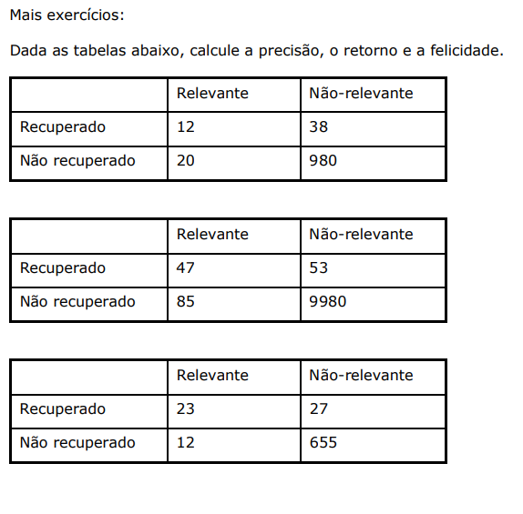

**Ex 1:**

P = 12/50 = 0.24

R = 12/32 = 0.375

F = 0.29

**Ex 2:**

P = 47/100 = 0.47

R = 47/132 = 0.356

F = 0.40

**Ex 3:**

P = 23/50 = 0.46

R = 23/35 = 0.6571

F = 0.54